Voter rankings reveal a shared low-dimensional polarization scale

Mahshad Habibpourparizi¹, Keena Lipsitz^{1,3}, Eric S. Simpson¹, Matthew Cheung, Simon A. Levin, Samuel S.-H. Wang^{1,2}

¹Electoral Innovation Lab, 22 Stockton Street, Princeton, New Jersey, USA 08544.
²Neuroscience Institute, Princeton University, Princeton, New Jersey, USA 08540.
³Queens College, City University of New York.

Abstract: Political dynamics in the U.S. are polarized despite the fact that individual voters have a complex range of views. To quantify the dimensionality of how voters express preferences, we analyzed over 350 ranked-choice elections, in which each voter provides his/her own ranking of candidates. We find that in any given election, most voters’ rankings are consistent with a shared conceptual arrangement of candidates along an axis, with the exact ranking specified by the voter’s own position and distance from each candidate. The aggregated positions of all voters comprise a spectrum describing the electorate. Electoral spectra are more one-dimensional for executive and federal offices than for local offices, suggesting that polarized voting behavior is strongly shaped by available choices. Using these spectra to simulate the impacts of conventional elections, approval voting, and all-party primaries, we identified scenarios in which the latter two rules were more likely to elect consensus and moderate candidates. A spectrum-based approach provides a means of predicting the long-term potential for electoral reforms to reduce polarization.

- Introduction
Conventional wisdom holds that Americans are increasingly polarized along a single dimension related to partisanship and ideology. In complex systems, dynamics on a low-dimensional continuum are often a precursor to instability and breakdown. It is therefore important to investigate as many facets of this polarization as possible to fully understand the extent of this low-dimensionality and how it might translate into frequent changes (and potential instability) in representative government.
Despite the conventional wisdom surrounding mass polarization, researchers actually disagree about whether or not Americans are polarized. Much of the debate emerges from scholars defining mass polarization in different ways. What unites much of this work, however, is its reliance on data collected from public opinion surveys. In this article, we investigate mass polarization using newly available cast vote records data. The growing use of ranked-choice voting methods across the United States now makes it possible to search for evidence of polarization in the most basic tool of democracy: the ballot.
Ranked-choice voting allows voters to mark their relative preferences for multiple candidates for an office on a single ballot. In instant runoff voting (often referred to as RCV)The candidate with the least support is eliminated and his/her votes assigned to the voter’s next choice; this is done repeatedly until one winner remains. In these elections, cast vote records provide a record of voters’ relative perceptions of candidates.
We use these cast-vote records to examine voters and candidates in a single shared parameter space defined by voter perceptions of candidate locations in a conceptual space. Importantly, we do not know what dimensions define this conceptual space. A significant amount of research suggests the dimensions might be related to partisanship, ideology, and dislike of partisan outgroups (Iyengar, Lelkes, Mason, etc.), but they could also be defined by other social cleavages, such as race (Hajnal &Trounstine).
In the following, we analyze the ballots from all ranked choice elections for which the cast-vote records are available and that feature more than two candidates, yielding a sample of 361 elections occurring between 2004 and 2025. This includes 297 general elections and 64 primaries (62 Democratic and 2 Republican). The elections span 27 jurisdictions, including 304 local elections, 42 state races, and 15 federal races. Elections presented a median of four candidates per race (range 3 to 66).

- The Dimensionality of Voter Preferences
Although scholars largely agree that Democrats and Republicans in Congress, as well as other party elites, are polarized (McCarty 2019), there is considerable disagreement about whether Americans themselves are, in part because scholars define polarization in a variety of ways (Lelkes 2016). The disagreement is strongest among scholars who define political polarization in terms of policy preferences. While some argue that irrespective of party, most Americans are moderate and non-ideological (Fiorina 2017; Baldassari and Gelman 2008)) others contend there is evidence that polarization on issues has increased over time (Abramowitz 2010), particularly among voters who identify as strong partisans There is little disagreement among scholars, however, that most voters have brought some of their most salient issue preferences in line with their party identification, a process referred to as sorting (Abramowitz 2010; Levendusky and 2009; Baldasarri and Gelman 2008). This can only happen if party leaders clearly express divergent preferences on salient issues so voters understand the “correct” party position.
Two other ways to measure polarization in the mass public involve assessing whether the ideological distribution of Americans has become bimodal and the extent to which the ideological commitments of Republicans and Democrats have diverged (Lelkes 2016). While survey measures of ideological commitment among the public show little evidence of bimodality (Lelkes 2016; Fiorina and Levendusky 2006; Fiorina et. al. 2005), there is evidence of ideological divergence among party identifiers (Lelkes 2016). There is also unequivocal evidence that affective polarization–the extent to which one dislikes people from the opposing party–is growing, as is the perception that Americans are polarized. Thus, Americans may view themselves as being polarized based on how they feel at the same time that they are not polarized–or only moderately so–in terms of their issue preferences and ideological commitments. These findings also suggest that the answer to the question of whether Americans are polarized crucially hinges on one’s definition of polarization and the measures one uses.
One thing that unites these various measures of polarization is they rely on survey data to investigate mass polarization. The manner in which most researchers analyze characteristics of public opinion data often involves making assumptions about what is a “liberal” and a “conservative” response (DiMaggio et al. 1996). This has led some researchers to develop methods for extracting latent ideology from item responses (Wright and Volodarsky 2023; Lelkes 2016; Hill and Tausanovitch 2015). Using common measures of ideology can also be problematic because they force respondents to evaluate their beliefs on a single dimension when in fact there is evidence that ideology often has multiple dimensions (Wright and Volodarsky 2023; Lupton et al. 2015; Feldman and Johnston 2013; Trier and Hillygus 2009). When phenomena exist in a multi-dimensional space, it becomes unclear what exactly polarization means.
In this study, we develop a method for understanding the structure of voter preferences from cast vote records, which allows us to ascertain the extent to which voter preferences do indeed fall along a single dimension. Only then do we then proceed to an examination of how polarized those preferences are.

- Characterizing the low dimensionality of voters using cast-vote records
We sought to place our analysis in the context of past approaches.to defining polarization, in which polarization has been suggested to be defined in terms of the spread of voters or candidates across a space of attitudes or issue stances (DiMaggio et al., 1996).
First, we tested whether voters behave as if they collectively view politics along a shared low-dimensional continuum. We tested the degree to which candidates could be placed along a single axis that was consistent with many voters’ expressed preferences. Any given voter’s preferences are defined as single-peaked (REF Duncan Black, Kenneth Arrow) if they correspond to at least one location on that axis, where closer candidates are preferred over those farther away. Specifically, if candidate A precedes candidate B on a voter’s ballot, his/her corresponding location on the axis should be closer to A than to B. For example, in a four-candidate race, if one voter’s ranking is A, B, C, D, others of D, C, B, A would be consistent with the candidates being arranged in order on an axis, and the voters being positioned at opposite ends of that axis. In other words, the ballots are single-peaked. Not all rankings are consistent. For example, a ranking of A, D, B, C cannot be reconciled with the two previously mentioned orderings.
To find an axis that could place the largest possible fraction of voters for an election, we used multidimensional scaling (MDS). Within each election we defined the distance between a pair of candidates as the reciprocal of the normalized frequency of appearing next to one another on a ballot. For frequencies of zero, we used twice the distance to the next-nearest candidate. These distances defined a dissimilarity matrix for use by the MDS algorithm to calculate the optimal candidate positions for that election.
We next defined γ (gamma) as the fraction of ballots for which a voter’s preferences were single-peaked along the axis. We compared γ for the MDS-generated orderings (γMDS) with a brute-force strategy in which we systematically evaluated all possible permutations of equally spaced candidates. We found that $γ_{MDS}$ was strongly correlated with the brute-force γ (Figure 1, Pearson’s r = +0.91, 253 elections, p< 0.00001), indicating that MDS was able to capture an ordered representation of candidates collectively shared by voters.
We found that γ decreased from 0.89 ± 0.05 (mean +/- SD) for 3 candidates to 0.69 ± 0.15 for 7 candidates. To determine whether this degree of low-dimensional voting behavior would have arisen by chance, we tested a random-preference model in which ballots had the same first-choice distribution of candidates as the actual data. We found that γ had consistently greater values than random-preference (k=3 to 7, p<10-12 by paired t-test) (Figure 2). Thus, voters tend to obey a shared representation of candidates that significantly constrains their preference along a single-dimensional continuum.
Here, describe the second “sanity check” method for calculating gamma (using ballots with 3 or more candidates listed) and recalculating the null gamma the same way (Figure 3).

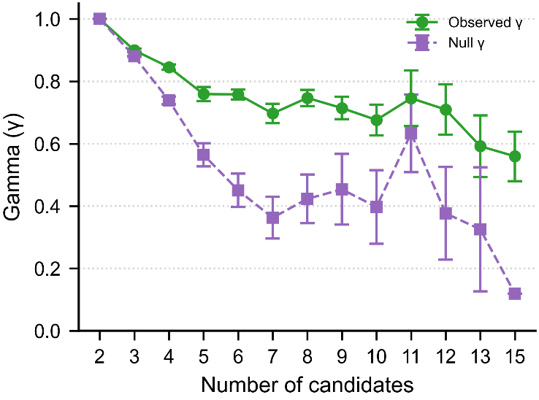
Figure 2
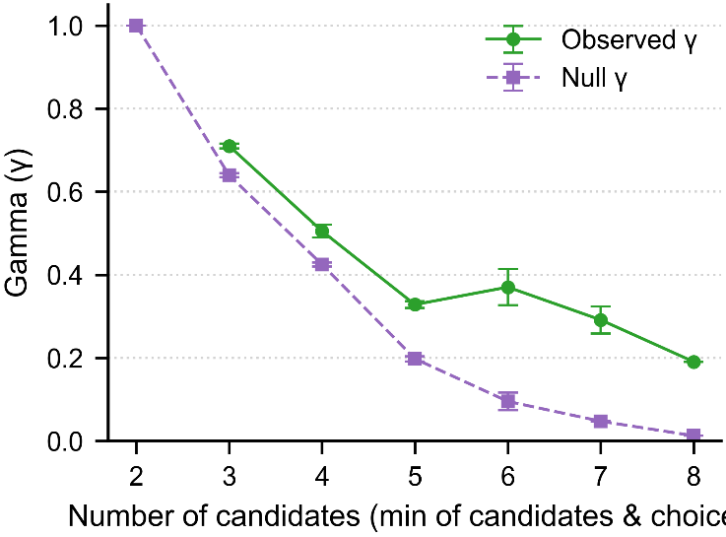
Figure 3

- Building a spectrum of voter preference using multidimensional scaling

A second measure of polarization is clustering of voters at opposite ends of a range, in a bimodal manner.
Parametric placement using MDS allowed us to place voters along the same dimension as candidates, resulting in a spectrum of voter preferences for each election. The intervals given to voters indicate their preferences, which depend on how close they are to each candidate along the axis. If no position along the axis aligns with the voter's preferences, that particular voter is not represented within the spectrum. An example (Figure 4).
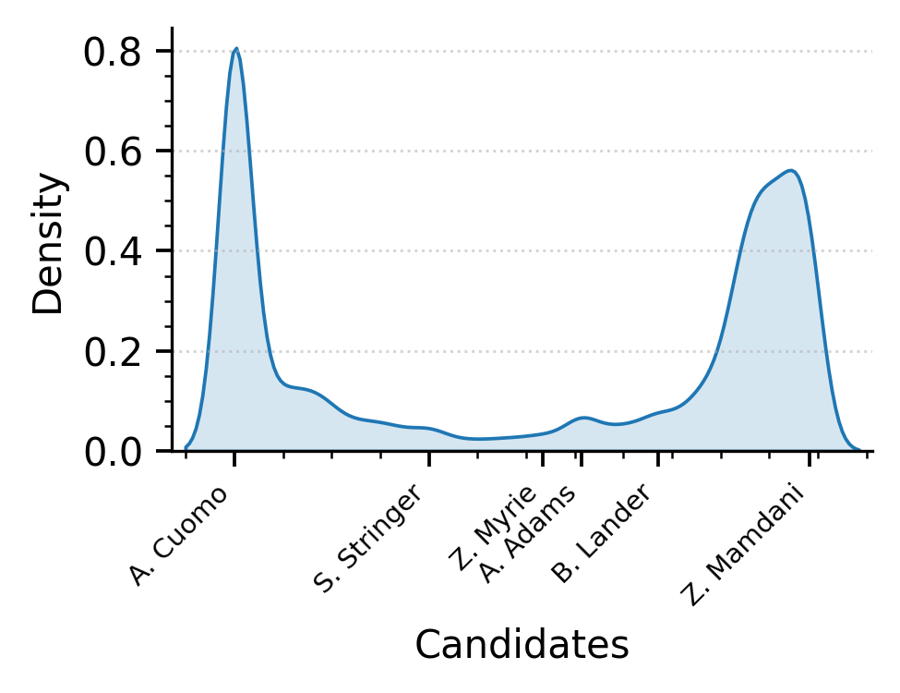
Figure 4

(Mahshad needs to redo this) To test the ability of this shared dimension of preference to account for election outcomes, we tabulated the results of the instant-runoff elections, omitting ballots inconsistent with the identified dimension. When off-dimension ballots were excluded, the winner changed in 13.3% of instances (41 elections). [DISCUSS DIFFERENCES BT LEVEL OF RACE IN CHART] These altered-winner elections did not have a larger fraction of off-dimension ballots than the other elections (gamma=mean+/-SD, t-test, p=0.x). How is the first-choice preference of off-dimension voters distributed, compared with on-dimension voters? These findings indicate that dimensionally consistent voters are usually but not always sufficient to decide the outcome of instant-runoff elections and that off-dimension ballots play a larger role in determining the outcome of state and local elections than in federal elections.

(a table summarizing this information)

- Bimodality
Voter distributions showed a general tendency to be peaked at the ends. These peaks were higher in partisan general elections than in nonpartisan elections and party primaries, consistent with a tendency for voters to cluster around each of the major-party candidates and treat the other party's candidate as least-favored.
Past research has suggested that elites are more separated along a single axis of polarization than voters (Will add citations). This raises the possibility that polarized voter behavior may depend on the availability of candidates. To test for candidate dependence, we compared voter and candidate spectra and found greater polarization among candidates.
This suggests that the existing environment can translate vote distributions to more extreme outcomes. [save this for simulation figure?]
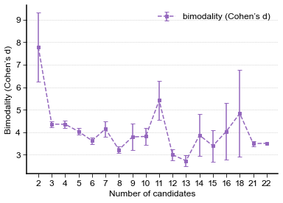
- Voter spectra show systematic variation by type of election
To test the ability of these voter spectra to detect differences in preference structure across types of elections, we averaged spectra for various types of elections. We found that partisan general elections showed two distinct peaks at each end of the spectrum (red trace), demonstrating an overall tendency for voters to cluster around each of the major-party candidates and treat the other party’s candidate as least-favored. These peaks were visible but considerably reduced in nonpartisan elections (black) and party primaries (cyan).
We also found that board positions, which usually appear downticket of high-profile races, showed weaker peaks than races for U.S. Senate, U.S. House, representative, and executive offices.

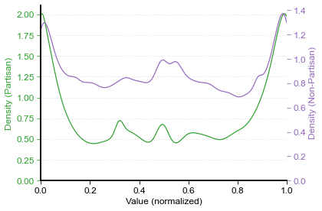

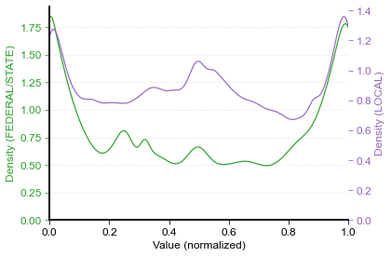

- Our measure of polarization, bimodality, and distance to the median voter
To quantify these differences, we investigated whether this translation depended on the available choices. We found that voter distribution was systematically different according to the type of election. Board positions, which usually appear downticket of high-profile races, showed weaker peaks than races for U.S. Senate, U.S. House, representative, and executive offices.

These differences suggested that voter spectra might vary systematically with different parameters of races. We displayed all spectra in a plane using t-distributed stochastic neighbor embedding (t-SNE), a common method for visualizing high-dimensional data. We found that coding of different variables showed distinctive patterns when superimposed on the same embedding.
Candidates were arranged along the spectrum. As necessitated by the nature of the analysis, two candidates were always at the far ends of the spectrum. In addition, candidates appeared along the axis. In partisan elections, major-party candidates were grouped on opposite ends of the spectrum.
Figures that need to be pointed at somewhere:
